At MCNY, a Look Back to the ‘Mad Men’ Era, Illustrated
September 11, 2014 12:05 PM
What do you get when you cross Norman Rockwell with Roy Lichtenstein? The Don Draper-era illustrations of Mac Conner. Writer Nancy Lazarus previewed the new exhibition of his work and sketched out her impressions.

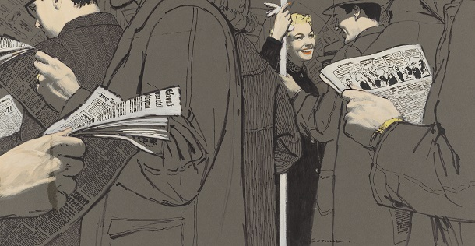
Mac Conner’s illustrations for “The Girl Who Was Crazy About Jimmy Durante” in Woman’s Day, September 1953 and below, for “How Do You Love Me” in Woman’s Home Companion, August 1950. (Courtesy of the artist)
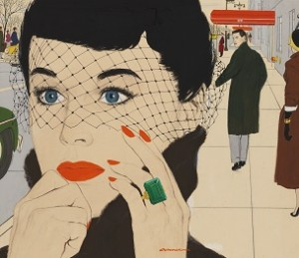At the ripe age of 100, McCauley “Mac” Conner is ready for his close-up. The illustrator made a special appearance this week at the opening of an exhibition of his work at the Museum of the City of New York (MCNY). “Mac Conner: A New York Life,” on view through January 19, 2015, provides an in-depth look at Conner’s career along with his working process.

“The period from the late 1940s through the early ’60s was Mac’s heyday,” said Terrence Brown, the exhibit’s guest curator and director of the Society of Illustrators, at Tuesday’s press preview. During the “Mad Men” era, Conner’s illustrations appeared on the covers of leading magazines of the day such as The Saturday Evening Post and the “Seven Sisters” women’s titles, like Good Housekeeping, Cosmopolitan, and Redbook.

“It was a vibrant time and Mac relished it,” said Sarah Henry, MCNY deputy director and chief curator. “Magazines were Mac’s favorite medium since they allowed more creative freedom. That’s also the time when he grew as a designer,” she added.
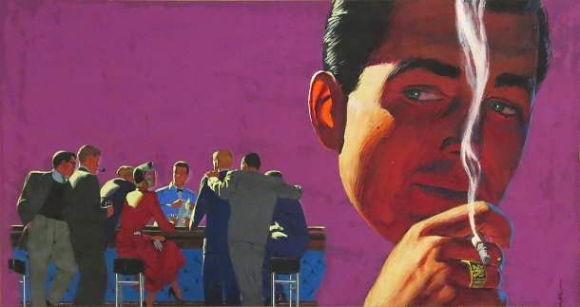
Mac Conner’s illustration for “All The Good Guys Died” in Cosmopolitan, January 1951. (Courtesy of the artist)
Conner worked for Neeley Associates, Bill Neeley’s studio that represented ten artists. Aside from magazines, Conner plied his trade for major Madison Avenue advertising accounts, including United Airlines and General Motors’ Plymouth automobile brand, before later turning to illustrating children’s books and the covers of romance novels.
Drawn from what Brown described as “a trove of art from Mac’s career,” the show features approximately 70 original artworks as well as reference photographs, pastel sketches, advertising tearsheets, and correspondence between editors and art directors.
Conner’s illustrations reflect the period in which he lived. Though he often portrayed traditional family scenes, the women were typically in control while the men served more as props, foreshadowing a change in male-female dynamics. Many of Conner’s works evoke darker Cold War-influenced themes, like the threat of crime and violence. And in typical ’50s fashion, the advertising glorified smoking, like one print ad that would make Mad Men’s Don Draper cringe: “Bringing smoking pleasures to the world.”
The exhibit is organized by theme and chronology, with areas devoted to Conner’s early work, fiction, advertising, process, anxieties of the era, and later work, accompanied by a brief video interview with the artist. “It was a happy journey doing these paintings,” Conner says in the footage. “As lives go it worked out pretty well.”
Nancy Lazarus is a frequent contributor to UnBeige.

